ASSIGNMENT 4

Name : Amitabh Srivastava
Roll number : 2301410016
Course : btech cse cyber security

Task 1: Batch Processing Simulation (Python)

Write a Python script to execute multiple .py files sequentially, mimicking batch processing.
CODE
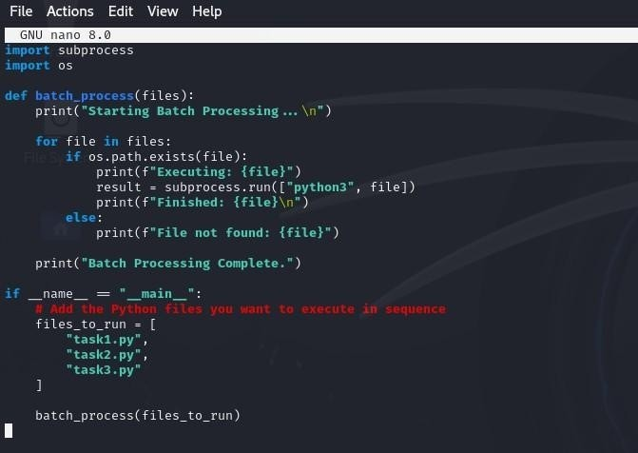
OUTPUT

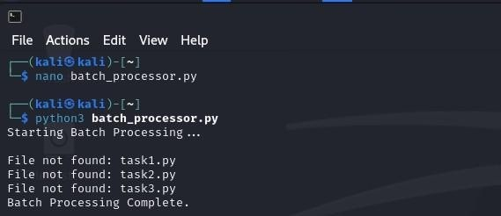

Task 2: System Startup and Logging
Simulate system startup using Python by creating multiple processes and logging their start and end into a log file.
CODE
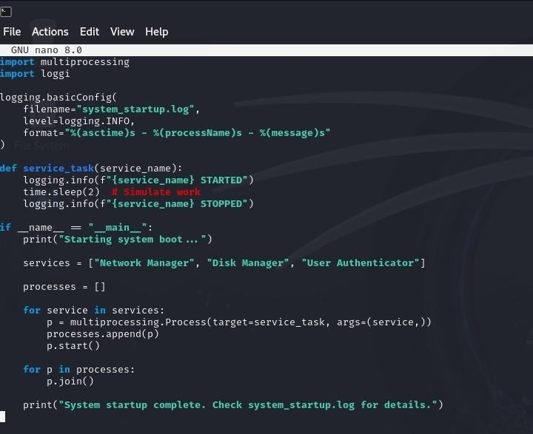

OUTPUT
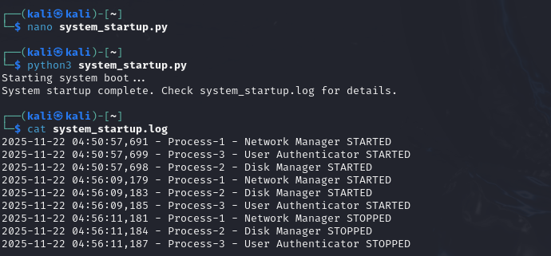

Task 3: System Calls and IPC (Python - fork, exec, pipe)
Use system calls (fork(), exec(), wait()) and implement basic Inter-Process Communication using pipes in C or Python.
- ipc_pipe_fork.py : parent and child communicate via an anonymous pipe (os.pipe + os.fork).
CODE
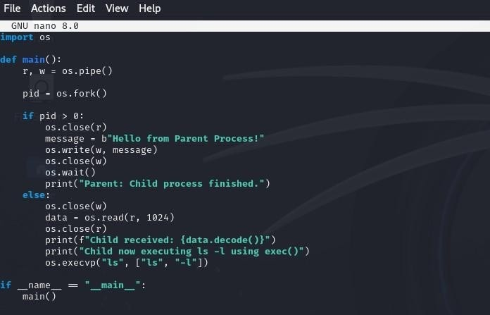

OUTPUT
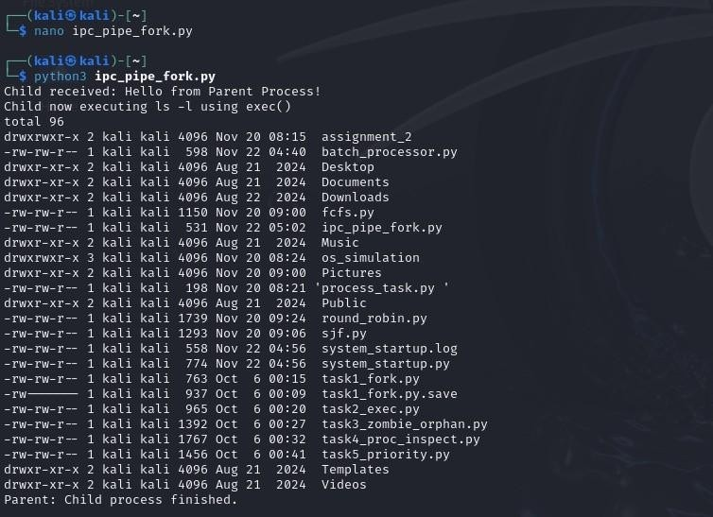

- exec_with_pipe.py: parent creates pipe, forks, child os.execvp() to run grep (or cat) and parent writes into pipe.
CODE
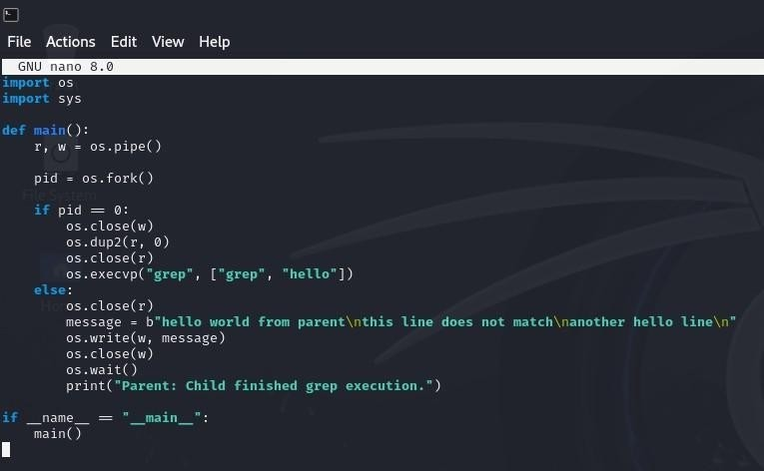
OUTPUT
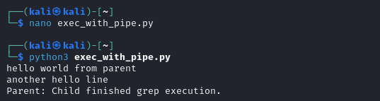

Task 4: VM Detection and Shell Interaction
Create a shell script to print system details and a Python script to detect if the system is running inside a virtual machine.
- Shell script to print system details
CODE
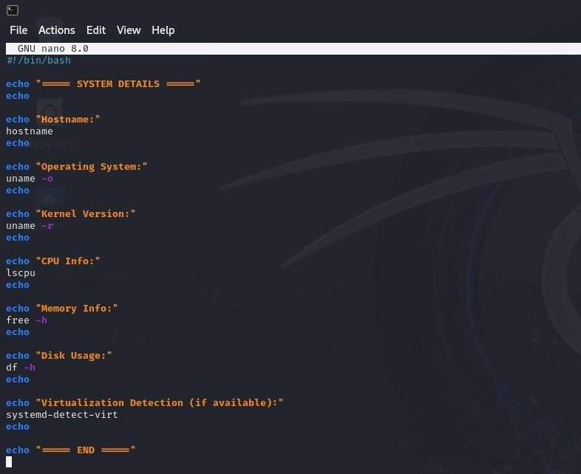

OUTPUT
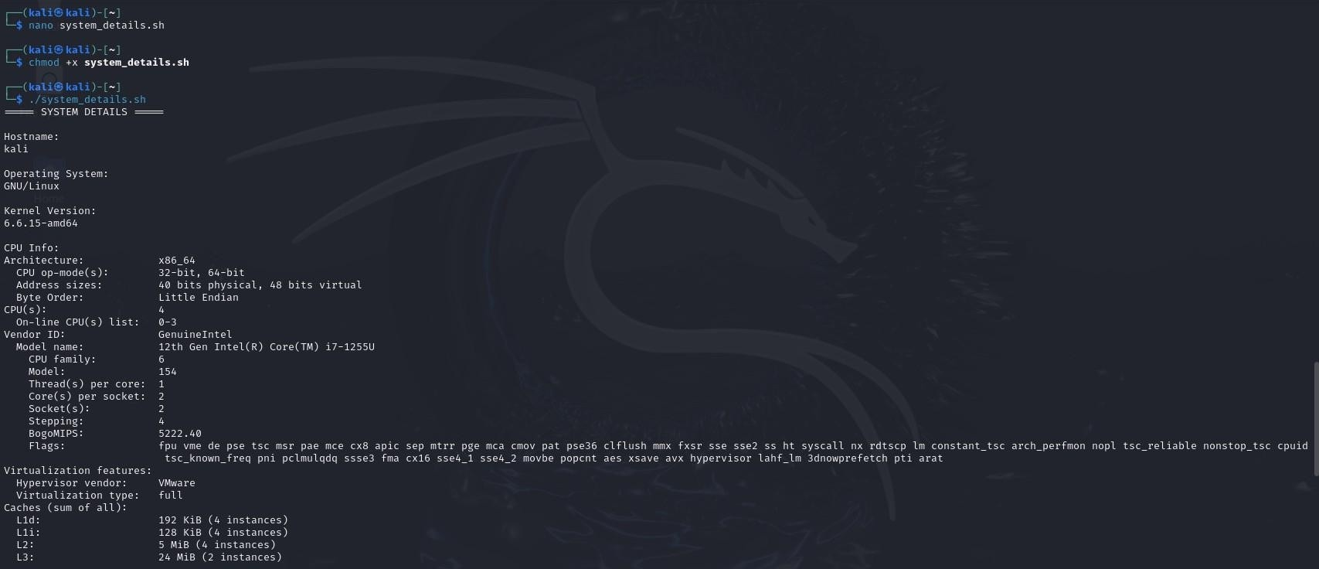
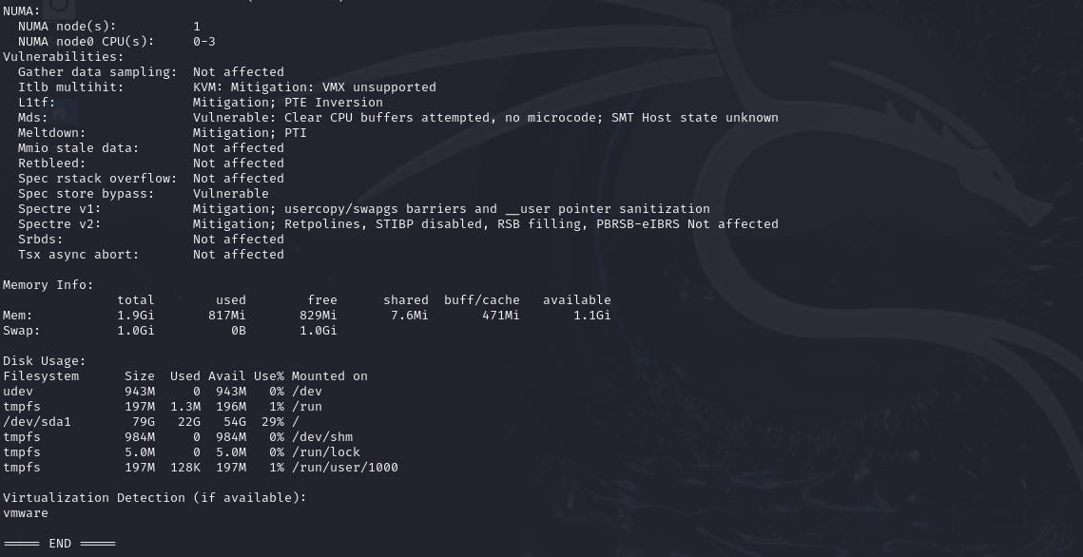

- Python script to detect VM: detect_vm.py
CODE
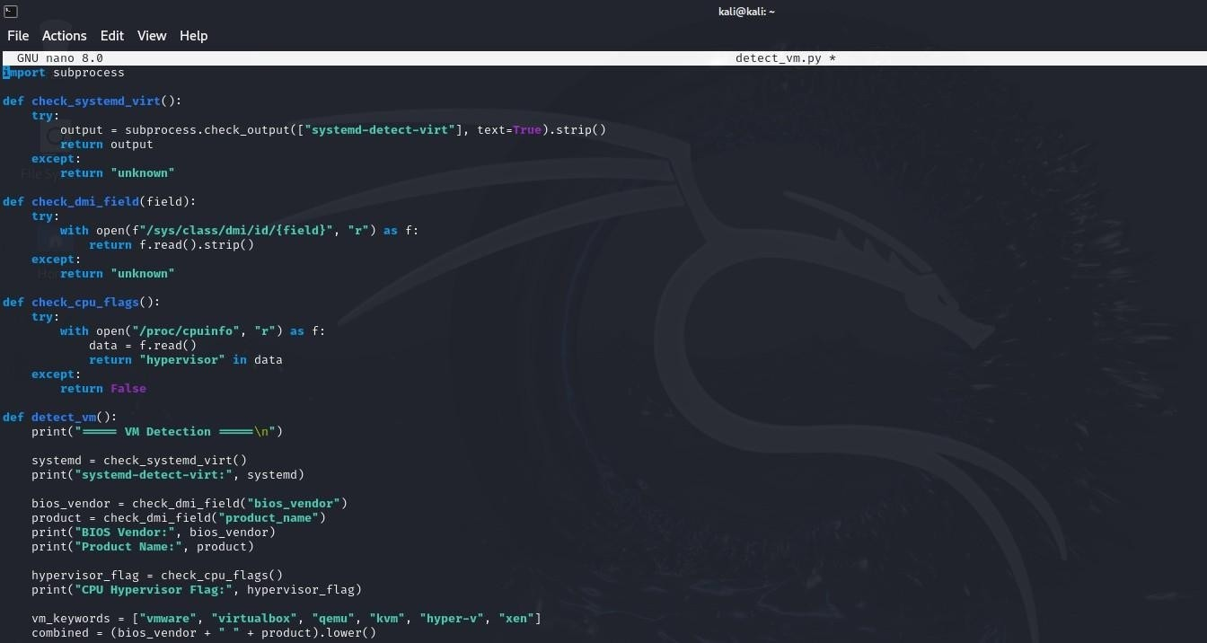
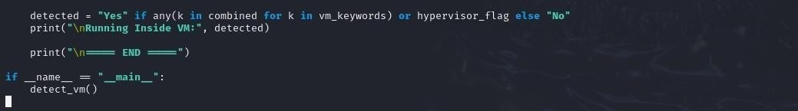

OUTPUT
